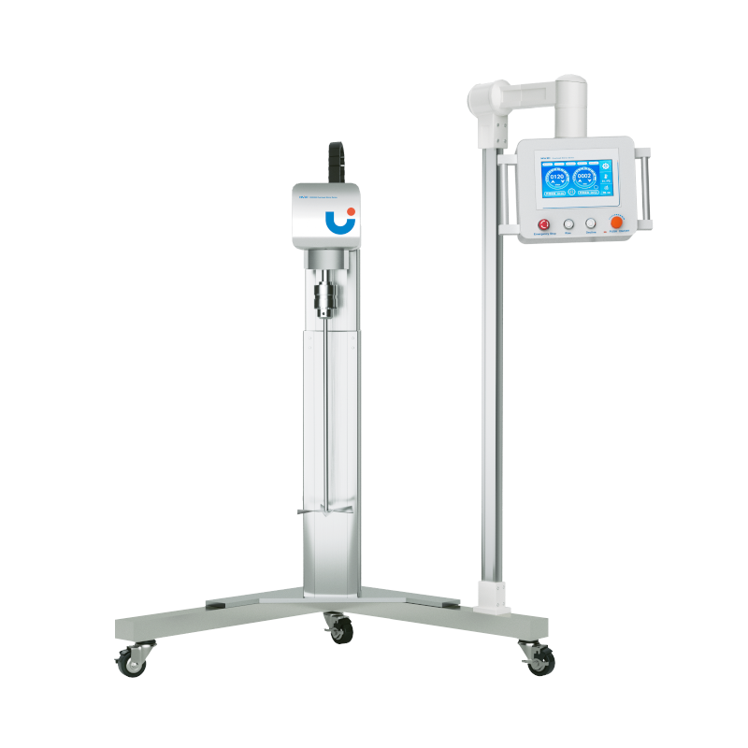

**RWD500 Large Power Mixer**

# **HJQ-2 Pneumatic Agitator**

# **Shaker**

# HT-S330 **Rotary Shaker**

**Application：**

RWD500 is a high-power mixer designed for laboratory or pilot plant and industrial production. The machine is designed with delicate structure and consists of driving motor, distance increasing mechanism and speed regulating controller. It is suitable for mixing and stirring of large capacity, low to medium and high viscosity, and can be widely used in daily chemical, pharmaceutical, chemical, material and energy industries.

**Main Features：**

* 0~9999min time range can be set arbitrarily;
* LCD screen real-time display of running time and speed;
* Use brushless DC motor, high efficacy, high torque, no pollution, no electric spark, safe and reliable;
* Equipped with electric lifting function, the lifting height can be adjusted according to the experimental demand, and the maximum stroke is up to 500mm;
* The base is equipped with movable casters with brakes, which is convenient and quick to move;
* Built-in safety circuit, overload and overheating automatic protection, worry-free continuous operation;
* The design of paddle through the hole, easy to operate and can run for a long time;
* Aluminum alloy lifting column, well-selected materials, stable operation, low noise, while ensuring lasting use of mechanical precision and electrical performance.

**Technical Parameters：**

|  |  |
| --- | --- |
| Model | RWD500 |
| Item No. | 1003016001 |
| Input voltage V | 200~240 |
| Frequency HZ | 50~60 |
| Motor type | DC brushless motor |
| Input power W | 1000 |
| Output power W | 500 |
| Stirring capacity L | 500 |
| Speed range rpm | 100~1500 |
| Speed accuracy rpm | ±1 |
| Speed display | LCD |
| Adjustment method | Buttons & Knobs & Touch |
| Timing range min | 0~9999 |
| Time display | LCD |
| Timing method | Buttons & Knobs & Touch |
| Lifting stroke mm | 500 |
| Lifting method | Electric lifting |
| Standard collet | Self lock type |
| Clamp range | 3~16mm |
| Allowable ambient temperature/ humidity | 5~40℃ 80% |
| Instrument size(mm) | 1150*650*1150 |
| Packing Size(mm) | 1300*1100*1400 |
| Instrument NW(kg) | 35 |
| Packing GW(kg) | 40 |